Optogenetically Induced Adult Behaviors

Note: The optogenetic *Drosophila* are light sensitive. Please keep covered by foil when possible.

Directions:

1. **Sample labeled MW**

Genotype: w, UAS-CSChrimson-venus (attP18); ; VT050660-GAL4 (attP2)

Bidaye et al., 2014

VT050660-GAL4 X UAS-mCD8-GFP

Brain Ventral Ganglion

1. Place red led light source facing down onto the table. Place the glass test tube labeled MW ~1 inch in front of the light source on the table. Give a 1 sec light pulse by flipping the switch on and off. What do you observe?
2. Give a longer light pulse 2-3 seconds. Do you observe any change in the behavior?
3. How long of a can you stimulate the flies with red light before the majority of the flies stop behaving? Why do you think they stop?
4. **Sample Labeled J**

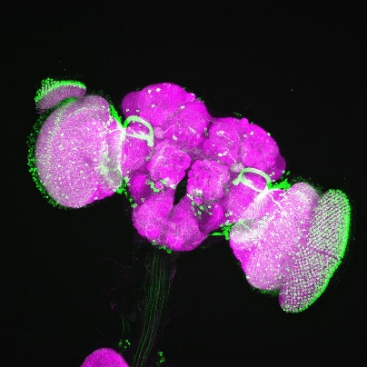 Genotype: w, UAS-CSChrimson-venus (attP18); ; R42E06-GAL4 (attP2)

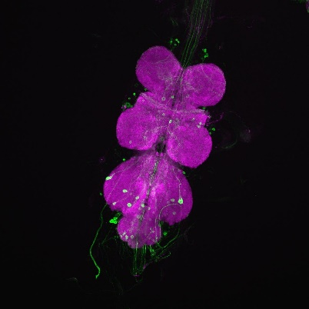

<http://flweb.janelia.org/cgi-bin/flew.cgi>

Jennet et al., 2012

Neuropil stained with nc82 (magenta)

R42E06-GAL4 X JFRC2-10XUAS-IVS-mCD8-GFP  
 Brain Ventral Ganglion

1. Place red led light source facing down onto the table. Place the glass test tube labeled J ~1 inch in front of the light source on the table. Give a 1 sec light pulse by flipping the switch on and off. What do you observe?
2. Give a longer light pulse 2-3 seconds. Do you observe any change in the behavior?
3. Lift up the Red LED light source, and hold it facing away from your eyes at a 45 degree angle towards the table above the glass vial. Turn on the light and slowly move the light forward and back, illuminating the flies. Is the behavior different?
4. How long can you stimulate the flies before the majority of the flies stop behaving?